Telecom Customer Churn Reduction
Eeswara Chaitanya Vutukuru
15 July 2018

Contents

- Introduction
  - Problem Statement
  - Data
- Methodology
  - Pre-processing
    - Identifying the missing values:
    - Conversion of variables into the required form
    - Exploratory Data Analysis a.k.a EDA
    - Distribution of the numeric variables
    - Outlier Analysis and Removal
    - Feature Selection
- Modelling
- Evaluation Metrics
  - Confusion Metrics
  - Area Under the ROC curve (AUC – ROC)
4.3 Evaluation of the model according to the problem statement
5. Code
5.1 Python Code
5.2 R-Code
6. Sample input and output

1. Introduction
1.1 Problem Statement
Churn (loss of customers to competition) is a problem for companies because it is more expensive to acquire a new customer than to keep your existing one from leaving. This problem statement is targeted at enabling churn reduction using analytics concepts.
1.2 Data
state | account length | area code | phone number | international plan | voice mail plan | number vmail messages
KS | 128 | 415 | 382-4657 | No | yes | 25
OH | 107 | 415 | 371-7191 | No | yes | 26
NJ | 137 | 415 | 358-1921 | No | no | 0
OH | 84 | 408 | 375-9999 | yes | no | 0
OK | 75 | 415 | 330-6626 | yes | no | 0
AL | 118 | 510 | 391-8027 | yes | no | 0
MA | 121 | 510 | 355-9993 | no | yes | 24
MO | 147 | 415 | 329-9001 | yes | no | 0
LA | 117 | 408 | 335-4719 | no | no | 0
WV | 141 | 415 | 330-8173 | yes | yes | 37

total day minutes | total day calls | total day charge | total eve minutes | total eve calls | total eve charge | total night minutes
265.1 | 110 | 45.07 | 197.4 | 99 | 16.78 | 244.7
161.6 | 123 | 27.47 | 195.5 | 103 | 16.62 | 254.4
243.4 | 114 | 41.38 | 121.2 | 110 | 10.3 | 162.6
299.4 | 71 | 50.9 | 61.9 | 88 | 5.26 | 196.9
166.7 | 113 | 28.34 | 148.3 | 122 | 12.61 | 186.9
223.4 | 98 | 37.98 | 220.6 | 101 | 18.75 | 203.9
218.2 | 88 | 37.09 | 348.5 | 108 | 29.62 | 212.6
157 | 79 | 26.69 | 103.1 | 94 | 8.76 | 211.8
184.5 | 97 | 31.37 | 351.6 | 80 | 29.89 | 215.8
258.6 | 84 | 43.96 | 222 | 111 | 18.87 | 326.4

total night calls | total night charge | total intl minutes | total intl calls | total intl charge | number customer service calls | Churn
91 | 11.01 | 10 | 3 | 2.7 | 1 | False.
103 | 11.45 | 13.7 | 3 | 3.7 | 1 | False.
104 | 7.32 | 12.2 | 5 | 3.29 | 0 | False.
89 | 8.86 | 6.6 | 7 | 1.78 | 2 | False.
121 | 8.41 | 10.1 | 3 | 2.73 | 3 | False.
118 | 9.18 | 6.3 | 6 | 1.7 | 0 | False.
118 | 9.57 | 7.5 | 7 | 2.03 | 3 | False.
96 | 9.53 | 7.1 | 6 | 1.92 | 0 | False.
90 | 9.71 | 8.7 | 4 | 2.35 | 1 | False.
97 | 14.69 | 11.2 | 5 | 3.02 | 0 | False.

Different variables present in the data set are:
Predictor Variables
Numeric Variables | Categorical Variables
account length | State
number vmail messages | area code
total day minutes | international plan
total day calls | voice mail plan
total day charge |  |  | Target Variable
total eve minutes |  |  | Churn (1/0)
total eve calls
total eve charge
total night minutes
total night calls
total night charge
total intl minutes
total intl calls
total intl charge
number customer service calls

- Methodology
2.1 Pre-Processing
Data pre-processing is a data mining technique that involves transforming raw data into an understandable format. Real-world data is often incomplete, inconsistent, and/or lacking in certain behaviours or trends, and is likely to contain many errors. Data pre-processing is a proven method of resolving such issues. Data pre-processing prepares raw data for further processing.
Below are several Data Pre-processing techniques used in this project.
    - Identifying the missing values:
First the given datasets are evaluated for the missing values. Since there are no missing values in the given dataset, the dataset is ready for the next level pre-processing techniques.
    - Conversion of variables into the required form:
It is very important to identify the type of each variable in each dataset and converting it to the required format. If we observe the ‘area code’ variable in the dataset, it appears to be a numeric variable (since it has the area codes in the form of numbers). But, it doesn’t make any sense if we take median / mean or any kind of numeric operations on this variable. Hence, this variable needs to be converted to a categorical type (i.e, factor in R).
    - Exploratory Data Analysis a.k.a EDA
Exploratory Data Analysis is defined as an approach to analyse the datasets to summarize their main characteristics.
For example below is a pie chart which shows the summary of the variable ‘Churn’.
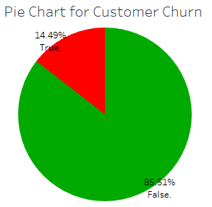
Since Churn variable consists of two values True or False, these are represented using red and green colours respectively in the above chart. So, here red represents the percentage of customers (or rows) in the Train_data file provided in the problem who has churned out whereas green represents the percentage of customers who have stayed with the company. Clearly from the chart it is observed that 14.49% of the customers have churned out which needs to be looked upon.

    - Distribution of the numeric variables:
Next part of the EDA is histogram plots. Histogram plot represents the distribution of the numeric data. It also helps us to understand the skewness of the data. Below are the figures which shows the histogram plots of each numeric variable in the Train_data.
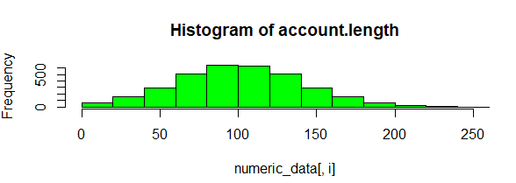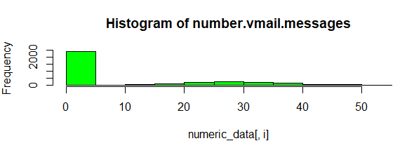
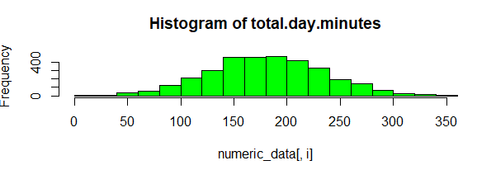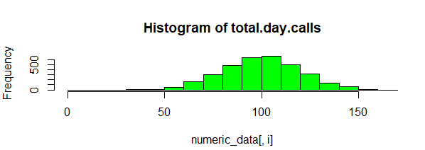

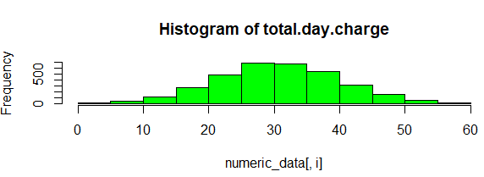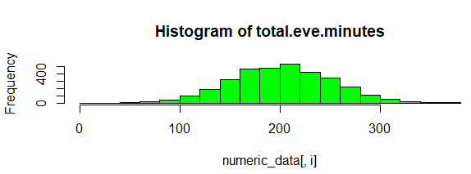

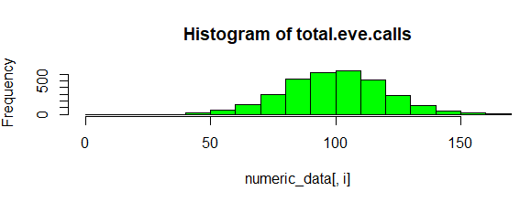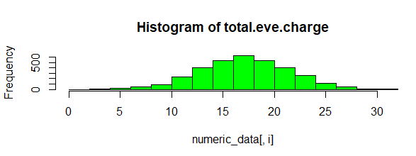

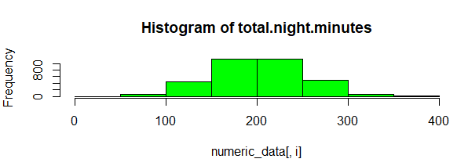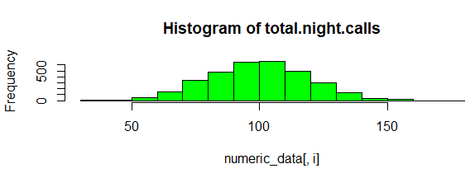

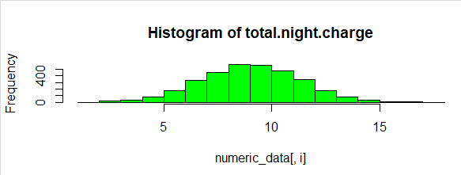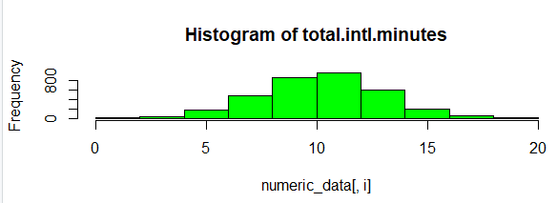

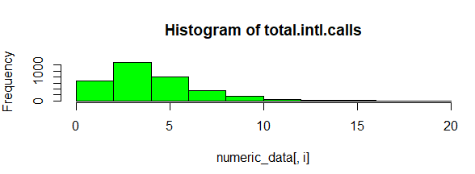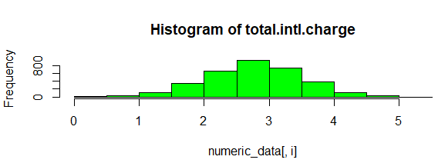

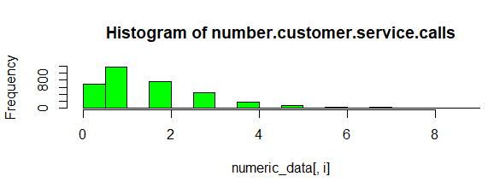
From the above plots, we can conclude that except the variables ‘number.vmail.messages’, ‘total.intl.calls’, ‘number.customer.service.calls’ remaining all variables are moderately skewed.
In the next session lets us analyse the outliers in the data using boxplots.
    - Outlier Analysis and Removal
An outlier is an observation that lies an abnormal distance from other values in a random sample from a population. Outliers can be detected using boxplots.
A box plot is constructed by drawing a box between the upper and lower quartiles with a solid line drawn across the box to locate the median. The following quantities (called fences) are needed for identifying extreme values in the tails of the distribution:
- lower inner fence: Q1 - 1.5*IQ
- upper inner fence: Q3 + 1.5*IQ
- lower outer fence: Q1 - 3*IQ
- upper outer fence: Q3 + 3*IQ
Since there are 15 numerical variables in our data set and the target variable has two categories (False and True), let us plot the outlier for each variable with respect to the Churn value. Here False is represented by 1 and True is represented by 2.
Below are the figures which represent the box plots for all the numerical variables which are represented by 3 variables in a row.
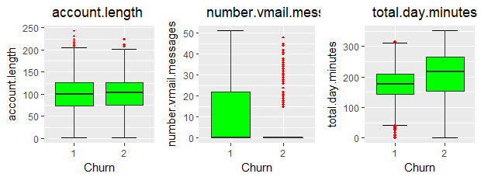
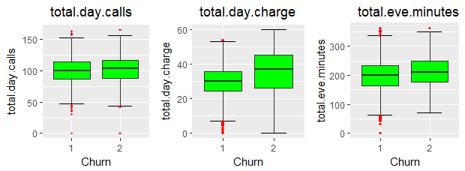
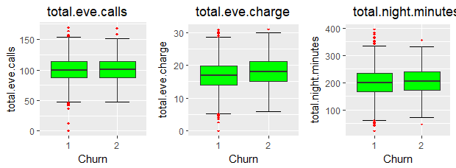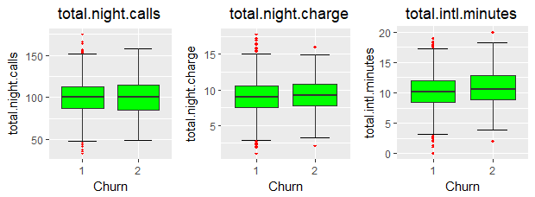
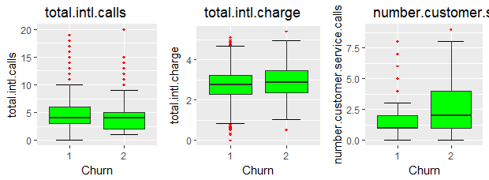
Box Plots for numeric variables in Train_data dataset
From the above figures if we observe the variable number.vmail.messages, it can be observed that there are many outliers. This is because most of the values for this variable are ‘0’s where Churn is True.
All these outliers are removed for feeding effective data to our model.
    - Feature Selection:
The most important part of building a machine learning model is Feature Selection. For carrying out feature selection, the dataset is divided into numeric and categorical data.
A correlation plot which shows the correlation between each numerical variable with each other numerical variable is plotted as shown below.
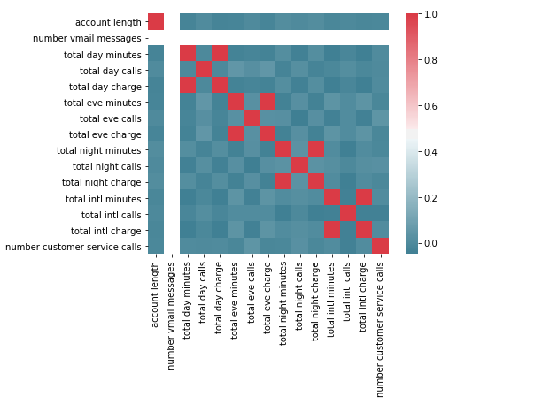
The above figure shows the correlation between the numerical variables on a scale of 0 to 1 using a heatmap with squares.
Thus, the plot clearly depicts that the variable ‘total day minutes’ is highly correlated with ‘total day charge’ (Since correlation > 0.8). It is obvious from the fact that the customers are charged as per the usage hence both the variables are proportional to each other. The same analysis applies to the variable set ‘total eve minutes’ & ‘total eve charge’ and ‘total night minutes’ & ‘total night charge’.
Hence one of the variables in these sets are to be removed as a part of feature selection since each of them carries the same information.
After removing these variables, the analysis is continued with the categorical variables. Each of the categorical variables are compared with the target variable ‘Churn’ such that the contribution of each of these variables for determining output is found. Chi-Square test is a statistical hypothesis testing method that is used for those to evaluate this ‘contribution to predict output’. The output of this hypothesis testing is the ‘p-value’ which determines whether we can include the predictor or remove it from our model. If p>0.05 then the variable is removed from the model else its retained.
Below is the output (p-values) from the chi-square test.
Variable | P-value
State | 0.002296
area code | 0.915056
international plan | -43.23
voice mail plan | 4.5914

Thus the predictors area code and voice mail plan are removed from the dataset. Along with these the customer phone number is removed from the list of predictors since it doesn’t carry any information and it would be illogical to include it.
    - Feature Scaling:
Feature scaling is a method used to standardize the range of independent variables or features of data. In data processing, it is also known as data normalization and is generally performed during the data pre-processing step.
In this project, the data is normalized that is converted to values which ranges from 0 to 1.
This becomes the last step of data pre-processing after which the data is divided into X_train and Y-train as input and target variables. The same process is repeated for the Test data to convert it into a usable format and X_test, Y_test are obtained accordingly. Also, it is made sure that both test and train data have the same data structure before building the model.

- Model Building and Selection
After the preparation or pre-processing of the data, the Train_data is given as input to the model. Here, since the test and train data are given separately the need for splitting the dataset into train and test. However, we can first divide the training data into test and train for the evaluation of the model developed before giving the actual test data. It helps us compare the results between the output of the model when it is exposed to a new set of data with that of a known data.
We cannot combine the Train_data and Test_data because it may result in overfitting of the model which isn’t a desirable approach. So, the data pre-processing steps are separately done, and the model is developed on top of them. While following this approach we need to make sure that there are same number of categories present in each categorical variable of test data is same as the number of categories present in the train data.
According to the problem statement, we can understand that this is a classification problem. So, the required model has to predict the output as 0 or 1 i.e, predict churn value as True or False. So, we can use several machine learning models from the list available for this problem.
Some of the available models are:
- Decision Tree Classifier
- Random Forest Classifier
- Knn Classifier
- SVM classifier
- Naïve Bayes Classifier
- Logistic regression modelling
Since we have a chance to implement any of these models we must identify the best model.
There are several model evaluation metrics available for evaluating the performance of a machine learning model which will be discussed in the following section. These metrics decide which model is the best suitable one for the data.
- Evaluation Metrics:
For a classification problem there are several classification metrics as shown below:
  - Confusion Matrix
A confusion matrix is an N X N matrix, where N is the number of classes being predicted. For the problem in hand, we have N=2, and hence we get a 2 X 2 matrix. Here are a few definitions, you need to remember for a confusion matrix :
- Accuracy : the proportion of the total number of predictions that were correct.
- Positive Predictive Value or Precision : the proportion of positive cases that were correctly identified.
- Negative Predictive Value : the proportion of negative cases that were correctly identified.
- Sensitivity or Recall : the proportion of actual positive cases which are correctly identified.
- Specificity : the proportion of actual negative cases which are correctly identified.
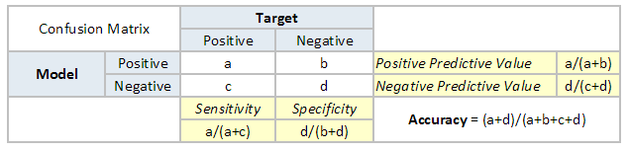

Area Under the ROC curve (AUC – ROC)
This is again one of the popular metrics used in the industry. The biggest advantage of using ROC curve is that it is independent of the change in proportion of responders. This statement will get clearer in the following sections.
Let’s first try to understand what is ROC (Receiver operating characteristic) curve. If we look at the confusion matrix below, we observe that for a probabilistic model, we get different value for each metric.
Hence, for each sensitivity, we get a different specificity.The two vary as follows:
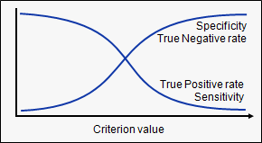
The ROC curve is the plot between sensitivity and (1- specificity). (1- specificity) is also known as false positive rate and sensitivity is also known as True Positive rate. Following is the ROC curve for the case in hand.
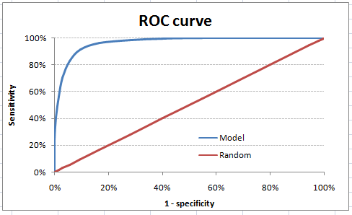
Let’s take an example of threshold = 0.5 (refer to confusion matrix). Here is the confusion matrix :
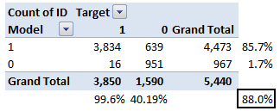
As you can see, the sensitivity at this threshold is 99.6% and the (1-specificity) is ~60%. This coordinate becomes on point in our ROC curve. To bring this curve down to a single number, we find the area under this curve (AUC).
Note that the area of entire square is 1*1 = 1. Hence AUC itself is the ratio under the curve and the total area. For the case in hand, we get AUC ROC as 96.4%. Following are a few thumb rules:
- .90-1 = excellent (A)
- .80-.90 = good (B)
- .70-.80 = fair (C)
- .60-.70 = poor (D)
- .50-.60 = fail (F)
We see that we fall under the excellent band for the current model. But this might simply be over-fitting. In such cases it becomes very important to in-time and out-of-time validations.
4.3 Evaluation of the model according to the problem statement:
Though there several metrics available for model evaluation, the model can be evaluated in a best way if we understand the business need.
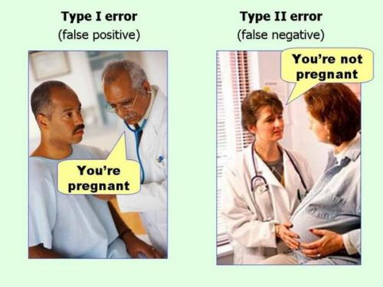
Let us understand this in an detailed manner using the above picture. In the first case the man was told that you are pregnant. But it doesn’t affect him much as he very well knows that he can’t. However, in the second case the lady was told that she was told that she isn’t pregnant. But this can lead to adverse effects since the woman might not take the necessary medical care that has to be taken.
Now, lets us understand this in the context of our problem. In our case type-1 error is:
Predicting the Churn value as True but the customer doesn’t churn out. So, this customer is provided with additional benefits to prevent him from Churning out though he won’t churn out which is some amount of loss to the Telecom company.
Type-2 error in our problem can be explained as follows:
Predicting the Churn value as False but the customer is going to Churn out. In this case the company will be at a high risk of losing the customer because the Churn value is predicted as False.
So, according to these errors the second one seems to be more significant one since our goal itself is to retain the customers from churning out. The metric which shows the best value of type-2 error is sensitivity because sensitivity is the rate of number of values predicted as true positive (i.e, True for Churn out) to the total number of positive values. Hence higher is the value of Sensitivity, better is the model.

Let us observe the values of different metrics from the below table.
Metrics  Model | Decision Tree | Random Forest | Logistic Regression |  | KNN |  | Naïve Bayes
TP | 124 | 84 |  | 40 |  | 22 | 67
TN | 1253 | 1405 |  | 1405 |  | 1417 | 1355
FP | 190 | 38 |  | 38 |  | 26 | 88
FN | 100 | 140 |  | 184 |  | 202 | 157
Accuracy | 82.6 | 89.3 |  | 86.68 |  | 86.3 | 85.3
F1 Score | 0.46 | 0.485 |  | 0.26 |  | 0.16 | 0.35
Sensitivity | 0.55 | 0.375 |  | 0.17 |  | 0.09 | 0.29
Precision | 0.39 | 0.68 |  | 0.51 |  | 0.45 | 0.43

From the above table we can observe that Decision Tree has the highest amount of Sensitivity among all the models. Which means it can identify the customers who are going to Churn out with high efficiency.
If we see the other models Random Forest, Logistic Regression and KNN, all of them have an accuracy of 80+ but they clearly fail when it comes to the Sensitivity value. This happens because of the biased nature of these models because of the higher percentage of ‘False’ values in the dataset (as seen in the Pie Chart in the previous section).
Now let us see the ROC curve for the Decision tree model developed below.
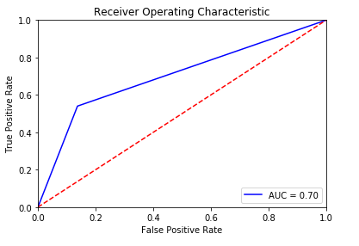
So, according to the interpretation of AUC value which is 0.70 it shows that this model is fair enough to proceed with.
- Code:-
5.1 Python Code:
#Importing the libraries
import pandas as pd
import numpy as np
import seaborn as sns
import matplotlib.pyplot as plt
% matplotlib inline
import math
import os
from sklearn import svm,datasets
import matplotlib.pyplot as plt
from scipy.stats import chi2_contingency
from sklearn.cross_validation import train_test_split
from sklearn import tree
from sklearn.metrics import accuracy_score
from sklearn.metrics import confusion_matrix
from sklearn.ensemble import RandomForestClassifier
from sklearn.linear_model import LogisticRegression
from sklearn.metrics import precision_score, \
recall_score, confusion_matrix, classification_report, \
accuracy_score, f1_score
from sklearn import neighbors, datasets
from sklearn.naive_bayes import GaussianNB
from sklearn import metrics

#Importing the dataset
os.chdir('C:/Users/chait/Desktop/Project1')
df = pd.read_csv('Train_data.csv')

#Data Preprocessing
df.dtypes
df.isnull().sum()
df['area code'] = df['area code'].astype(object)
str(df['area code'])
df.info()
df.drop(['phone number'],axis = 1,inplace = True)

#Dividing the numeric and categorical variables
cnames = df.select_dtypes(exclude = ['object'])
numeric_variables = list(cnames.columns.values)

#Saving Categoical columns
cat_data = df.select_dtypes(include = ['object'])
categorical_variables = list(cat_data.columns.values)

#Assigning levels to the categories
for i in range(0,df.shape[1]):
if(df.iloc[:,i].dtypes == 'object'):
df.iloc[:,i] = pd.Categorical(df.iloc[:,i])
df.iloc[:,i] = df.iloc[:,i].cat.codes
for i in categorical_variables:
df[i] = df[i].astype(object)

#Exploratory Data Analysis
sns.countplot(x="Churn",data=df)

#Outlier Analysis
plt.boxplot(df['account length'])
for i in numeric_variables:
print(i)
q75,q25 = np.percentile(df.loc[:,i],[75,25])
iqr = q75-q25

min = q25 - (iqr*1.5)
max = q75 + (iqr*1.5)
df.loc[df.loc[:,i]<min ,i] = np.nan
df.loc[df.loc[:,i]>max ,i] = np.nan

#Replacing the outliers with median value
df = df.fillna(df.median(),inplace = True)

for i in categorical_variables:
df[i] = df[i].astype(object)

cnames = df.select_dtypes(exclude = ['object'])
numeric_variables = list(cnames.columns.values)

#Feature Selection
f,ax = plt.subplots(figsize =(7,5))

#Generate correlation matrix
corr = cnames.corr()

#Plot using seaborne library
sns.heatmap(corr, mask =np.zeros_like(corr, dtype = np.bool),
cmap =sns.diverging_palette(220, 10, as_cmap =True),
square = True, ax = ax)
df.drop(['total day minutes','total eve minutes','total night minutes'],axis = 1,
inplace = True)

cnames = df.select_dtypes(exclude = ['object'])
numeric_variables = list(cnames.columns.values)

#Feature scaling/Normalization
%matplotlib inline
for i in numeric_variables:
plt.hist(df[i], bins ='auto')
plt.show

#Normalization of the data
for i in numeric_variables:
print(i)
a = df[i].max()
b = df[i].min()
df[i] = (df[i]- b)/(a-b)
#Chi-sqare test
categorical_variables = categorical_variables[:-1]
for i in categorical_variables:
print(i)
chi2, p, dof, ex =chi2_contingency(pd.crosstab(df.Churn,df[i]))
print(p)
df.drop(['area code','voice mail plan'],axis = 1, inplace =True)
X_train = df.iloc[:,0:14]
Y_train = df.iloc[:,14]
Y_train = Y_train.astype('int')

#########Importing the test dataset#########

df = pd.read_csv('Test_data.csv')

#Data Preprocessing

df.isnull().sum()
df['area code'] = df['area code'].astype(object)
df.drop(['phone number'],axis = 1,inplace = True)

#Dividing the numeric and categorical variables
cnames = df.select_dtypes(exclude = ['object'])
numeric_variables = list(cnames.columns.values)

#Saving Categoical columns
cat_data = df.select_dtypes(include = ['object'])
categorical_variables = list(cat_data.columns.values)

#Assigning levels to the categories
for i in range(0,df.shape[1]):
if(df.iloc[:,i].dtypes == 'object'):
df.iloc[:,i] = pd.Categorical(df.iloc[:,i])
df.iloc[:,i] = df.iloc[:,i].cat.codes
for i in categorical_variables:
df[i] = df[i].astype(object)

#Feature Selection
df.drop(['total day minutes','total eve minutes','total night minutes'],axis = 1,
inplace = True)
df.drop(['area code','voice mail plan'],axis = 1, inplace =True)

cnames = df.select_dtypes(exclude = ['object'])
numeric_variables = list(cnames.columns.values)

#Saving Categorical columns
cat_data = df.select_dtypes(include = ['object'])
categorical_variables = list(cat_data.columns.values)

#Normalization of the data
for i in numeric_variables:
print(i)
a = df[i].max()
b = df[i].min()
df[i] = (df[i]- b)/(a-b)

X_test = df.iloc[:,0:14]
Y_test = df.iloc[:,14]

#Converting the target variable to int type for
Y_test = Y_test.astype('int')
Y_train = Y_train.astype('int')

#Decision Tree
clf = tree.DecisionTreeClassifier(criterion ='entropy').fit(X_train,Y_train)

#Predict
Y_pred = clf.predict(X_test)
fpr, tpr, threshold = metrics.roc_curve(Y_test, Y_pred)

#Check accuracy of the model
print ('Accuracy:', accuracy_score(Y_test, Y_pred)*100)
print ('F1 score:', f1_score(Y_test, Y_pred))
print ('Sensitivity or Recall:', recall_score(Y_test, Y_pred))
print ('Precision:', precision_score(Y_test, Y_pred))
print ('\n clasification report:\n', classification_report(Y_test, Y_pred))
print ('\n confussion matrix:\n',confusion_matrix(Y_test, Y_pred))

#Random Forest
clf = RandomForestClassifier()
clf.fit(X_train, Y_train)
Y_pred = clf.predict(X_test)
print ('Accuracy:', accuracy_score(Y_test, Y_pred)*100)
print ('F1 score:', f1_score(Y_test, Y_pred))
print ('Recall:', recall_score(Y_test, Y_pred))
print ('Precision:', precision_score(Y_test, Y_pred))
print ('\n clasification report:\n', classification_report(Y_test, Y_pred))
print ('\n confussion matrix:\n',confusion_matrix(Y_test, Y_pred))

#Logistic Regression
logreg = LogisticRegression()
logreg.fit(X_train, Y_train)
Y_pred = logreg.predict(X_test)
print ('Accuracy:', accuracy_score(Y_test, Y_pred)*100)
print ('F1 score:', f1_score(Y_test, Y_pred))
print ('Recall:', recall_score(Y_test, Y_pred))
print ('Precision:', precision_score(Y_test, Y_pred))
print ('\n clasification report:\n', classification_report(Y_test, Y_pred))
print ('\n confussion matrix:\n',confusion_matrix(Y_test, Y_pred))

#Testing the performance of other models
#KNN classifier
knn=neighbors.KNeighborsClassifier()
knn.fit(X_train,Y_train)
Y_pred = knn.predict(X_test)
print ('Accuracy:', accuracy_score(Y_test, Y_pred)*100)
print ('F1 score:', f1_score(Y_test, Y_pred))
print ('Recall:', recall_score(Y_test, Y_pred))
print ('Precision:', precision_score(Y_test, Y_pred))
print ('\n clasification report:\n', classification_report(Y_test, Y_pred))
print ('\n confussion matrix:\n',confusion_matrix(Y_test, Y_pred))

#SVM
model = svm.SVC(kernel='linear', C=1,gamma =1)
model.fit(X_train,Y_train)
Y_pred = model.predict(X_test)
print ('Accuracy:', accuracy_score(Y_test, Y_pred)*100)
print ('F1 score:', f1_score(Y_test, Y_pred))
print ('Recall:', recall_score(Y_test, Y_pred))
print ('Precision:', precision_score(Y_test, Y_pred))
print ('\n clasification report:\n', classification_report(Y_test, Y_pred))
print ('\n confussion matrix:\n',confusion_matrix(Y_test, Y_pred))

#Naive Bayes
gnb = GaussianNB()
gnb.fit(X_train,Y_train)
Y_pred = gnb.predict(X_test)
print ('Accuracy:', accuracy_score(Y_test, Y_pred)*100)
print ('F1 score:', f1_score(Y_test, Y_pred))
print ('Recall:', recall_score(Y_test, Y_pred))
print ('Precision:', precision_score(Y_test, Y_pred))
print ('\n clasification report:\n', classification_report(Y_test, Y_pred))
print ('\n confussion matrix:\n',confusion_matrix(Y_test, Y_pred))

#ROC PLot
# calculate the fpr and tpr for all thresholds of the classification
fpr, tpr, threshold = metrics.roc_curve(Y_test, Y_pred)
roc_auc = metrics.auc(fpr, tpr)

plt.title('Receiver Operating Characteristic')
plt.plot(fpr, tpr, 'b', label = 'AUC = %0.2f' % roc_auc)
plt.legend(loc = 'lower right')
plt.plot([0, 1], [0, 1],'r--')
plt.xlim([0, 1])
plt.ylim([0, 1])
plt.ylabel('True Positive Rate')
plt.xlabel('False Positive Rate')
plt.show()
#######################END#####################

5.2 R-Code:
rm(list = ls())

#Load Libraries
x = c('ggplot2', 'corrgram', 'DMwR', 'caret', 'randomForest', 'unbalanced', 'C50', 'dummies',
'e1071', 'Information','MASS','rpart', 'gbm', 'ROSE')

#install.packages(x)
lapply(x, require, character.only = TRUE)
rm(x)
library(ggplot2)
#Importing the dataset
setwd('C:/Users/chait/Desktop/Project1')
df = read.csv('Train_Data.csv')

#Data preprocessing
sum(is.na(df))
head(df)
str(df)
df$state = as.factor(as.character(df$state))
df$area.code = as.factor(as.character(df$area.code))
str(df$state)
str(df$area.code)
df = subset(df,select =-c(phone.number))

#Exploratory data analysis
library(reshape)
table(df$Churn)
pie(table(df$Churn),main = 'Pie chart for Customer Churn',radius = 1)

#Exploratory data analysis
for(i in 1:ncol(numeric_data))
{
hist(numeric_data[,i],main = paste("Histogram of" , cnames[i]),col='green',border = 'black')
}
imppred <- randomForest(Churn ~ ., data = df,
ntree = 100, keep.forest = FALSE, importance = TRUE)
importance(imppred, type = 1)

#Seperating the numeric data
numeric_index = sapply(df,is.numeric)
numeric_data = df[,numeric_index]

cnames = colnames(numeric_data)

#Encoding categorical variables
for(i in 1:ncol(df)){
if(class(df[,i]) == 'factor'){
df[,i] = factor(df[,i], labels =(1:length(levels(factor(df[,i])))))
}
}

#Outlier analysis
for (i in 1:length(cnames)){
assign(paste0("gn",i),ggplot(aes_string(y = cnames[i],x = "Churn"),data = subset(df))+
stat_boxplot(geom = "errorbar", width = 0.5)+
geom_boxplot(outlier.colour = 'red', fill = "green", outlier.shape = 18,
outlier.size = 1, notch = FALSE) +
theme(legend.position = "bottom")+
labs(y=cnames[i],x = "Churn")+
ggtitle(paste(" ", cnames[i])))
}
#Plotting plots together
gridExtra::grid.arrange(gn1,gn2,gn3,ncol = 3)
gridExtra::grid.arrange(gn4,gn5,gn6,ncol = 3)
gridExtra::grid.arrange(gn7,gn8,gn9,ncol = 3)
gridExtra::grid.arrange(gn10,gn11,gn12,ncol = 3)
gridExtra::grid.arrange(gn13,gn14,gn15,ncol = 3)

#Imputing the outlier values with knn Imputation method
for( i in cnames){
print(i)
val = df[,i][df[,i] %in% boxplot.stats(df[,i])$out]
df[,i][df[,i] %in% val] = NA
}

df = knnImputation(df, k=80)

#Feature Selection | Correlation plot for numeric variables
library(corrplot)

m = cor(df[,numeric_index])
corrplot(m, method="square")

factor_index = sapply(df,is.factor)
factor_data = df[,factor_index]

for(i in 1:4)
{
print(names(factor_data[i]))
print(chisq.test(table(factor_data$Churn,factor_data[,i])))

}

df1 = subset(df, select = -c(total.day.charge,total.eve.charge,total.night.charge,total.intl.charge,area.code,voice.mail.plan))

numeric_index = sapply(df1,is.numeric)
numeric_data = df1[,numeric_index]

df_train=df1

#Feature Scaling | Normalizing the data
for( i in colnames(numeric_data))
{
print(i)
df_train[,i] = (df_train[,i]- min(df_train[,i]))/
(max(df_train[,i] - min(df_train[,i])))
}

############ Test Data processing############

#Importing the test data
df = read.csv('Test_data.csv')
sum(is.na(df))
head(df)
str(df)

#Basic pre-processing
df$state = as.factor(as.character(df$state))
df$area.code = as.factor(as.character(df$area.code))
str(df$area.code)
datatypes = sapply(df,class)
for(i in 1:ncol(df)){
if(class(df[,i]) == 'factor'){
df[,i] = factor(df[,i], labels =(1:length(levels(factor(df[,i])))))
}
}
#Feature Selection in Test Data
df1 = subset(df, select = -c(total.day.charge,total.eve.charge,total.night.charge,total.intl.charge,phone.number,area.code,voice.mail.plan))

df_test=df1

#Feature scaling | Normalization
for( i in colnames(numeric_data))
{
print(i)
df_test[,i] = (df_test[,i]- min(df_test[,i]))/
(max(df_test[,i] - min(df_test[,i])))
}

#Building and training a decision tree model
#install.packages('C50')
library(C50)
C50_model = C5.0(Churn ~.,df_train, trails = 100, rules = TRUE)
summary(C50_model)
#Predicting the output
C50_predictions = predict(C50_model,df_test[,-15],type = 'class')

#Evaluate the performance of classification model
Confmatrix_C50 = table(df_test$Churn,C50_predictions)
confusionMatrix(Confmatrix_C50)

#Building and training a Random Forest Model
#RF
RF_model = randomForest(Churn ~.,df_train, importance = TRUE, ntree=100)
RF_Predictions = predict(RF_model, df_test[,-15])
Confmatrix_RF = table(df_test$Churn,RF_Predictions)
confusionMatrix(Confmatrix_RF)

#############################################END########################

6.Sample input and output
The below R and python codes contain a sample of the test data and the corresponding output obtained by the model.
Below are the sample input and output datasets for both R and Python respectively.

References
https://learning.edwisor.com/
https://machinelearningmastery.com
https://www.analyticsvidhya.com

